**CS 2302 Data Structures**

**Fall 2019**

**Lab Report #3**

Due: October 4, 2019

Professor: Olac Fuentes

TA: Anindita Nath

**Introduction**

Lab 2: Linked Lists focuses on developing a SortedList and List class to compare the Big-O runtimes of specific functions. The functions whose runtimes will be compared include Print, Insert, Delete, Merge, IndexOf, Clear, Min, Max, HasDuplicates, and Select. The Print method prints all the elements of a list. The Delete and Insert methods remove or add a designated integer to the list. Merge combines two SortedLists or Lists. Clear removes all Nodes from a list. Min and Max return the minimum and maximum values of a list. HasDuplicates returns a Boolean value based on whether the list has Nodes with the same data and Select returns the kth smallest element. Since a major part of this lab focuses on comparing the runtime complexity, the theoretical runtime for each algorithm is calculated and compared with the collected results. In the end, a summary of the runtimes, expressed in Big-O notation, will be displayed.

**Proposed Solution Design and Implementation**

NOTE: The report will continue to reference n, which stands for the number of Nodes in the designated Linked List.

Print

In order to meet the function definition requirements, the only parameter of the Print function is self for the SortedList and List implementation. Both functions print “List is empty” if the list is empty. Otherwise, each node is iterated through and the data is printed. One important design choice that I made was printing if the list was empty. Initially, I was not going to do so, but I thought that it would be crucial to inform the user if their list was empty. For the average and worst case, for SortedList and List, the runtime complexity will be T(n) = n which yields O(n). This is because all the elements will be iterated through. The best case scenario would be if the head pointed to None, in which case the function would terminate immediately. This would result in T(n) = 1, yielding O(1).

Insert

Both the SortedList and List implementation of Insert take self and the integer to insert as the parameter. Although both functions insert the integer into the list, their executions are different. For List, the integer is appended at the end of the list, since order does not matter. The function will first check if the List is empty, in which case it will assign the head and tail to the new node. If the head is not None, then the new Node will be added after the tail and consequently the tail will be updated. I thought that appending the Node was a very important design decision. Rather than iterating through the entire list just to reach the end, the Node could be appended after the tail. Since order does not matter, appending is the optimal solution. As for the runtime complexity, the best, average, and worst case would simply involve a Node being appended. Thus, in all cases, only pointers are updated and a new Node is created. This results in a runtime complexity of T(n) = 1, yielding O(1).

For SortedList, the head is first checked. If the head is None, then the tail and the head will point to the new node. If the list is not empty, then it is iterated through until data is found that is greater than or equal to the integer to add. Once the Node with the integer data is added, the iteration stops. Since iterating through the list can result in a longer runtime complexity, the data at the head and tail are first check. If the integer’s value is less than the head’s value, then it is prepended. Likewise, if the integer’s value is greater than or equal to the tail, it is appended. I thought that this was a very important check, since it would be wasteful to iterate through the entire list just to append the Node. As for the runtime complexity, the best case would be T(n) = 1 and O(1) since the integer could be inserted at the head or tail of the list immediately. For the average and worst case, the list will be iterated through until the correct position is found resulting in T(n) = n and O(n).

Delete

Both the SortedList and List Delete function receive self and the integer to remove as a parameter. Additionally, both algorithms remove all instances of the integer. For the SortedList, the head is first checked. If the head is None, then the function terminates. Otherwise, a dummy Node is used and points to the head of the list. A pointer then points to the dummy Node and traverses the list until it reaches the node before integer’s occurrence. All instances of the integer are then deleted. If the integer does not exist in the list, then the traversal is terminated. For example, if the list was 1, 2, 4, 6 and the integer to delete was 3, the list would be traversed until it reached 2. Since 4 is greater than 3, it can be concluded that 3 is not in the list, ending the traversal. As for the dummy Node, I chose to use it to instantly update the head. If the list only contained the value to be deleted several times, then the head would need to be updated at the end. By using the dummy node, I was able to assign the head to the dummy Node’s next Node in constant time. As for the runtime complexity, the best case would be if the integer to be removed was greater than the tail or less than the head. The function would then stop resulting in T(n) = 1 or O(1). For the average and worst case, the list would have to be iterated through resulting in T(n) = n or O(n).

For List, if the list is empty, then the function terminates. If not, then the same structure with a dummy Node is used. A pointer is initially assigned to the dummy Node and iterates through the list, removing instances of the integer as it goes. However, it is important to note that since the list is not ordered, the entire list must be checked. This varies from SortedList, because an integer’s location is unknown. Due to this, the worst case and average runtime complexity will be T(n) and O(n). For the best case, the list will be empty, resulting in the T(n) = 1 and O(1). Since most of the Lists used will actually contain data, this best case scenario is very rare.

Merge

Both the SortedList and List accept a corresponding list and self as a parameter. For SortedList, a dummy Node was used to reference the original list. One pointer was then assigned to the original list and the other was assigned to the second list. If the current node in the second list had data less than or equal to the current Node in the first list, then the node was removed and added to the original list. If not the pointer to the original list was updated to the next node. In order to make the algorithm more efficient and organized, I used a helper method called FindEndOfNodesToAdd. This function would essentially return the segment of Nodes that contained values less than or equal to the next Node in the original list. Thus, rather than inserting and removing nodes one at a time, larger pieces could be added. As for runtime complexity, in the best case, all of one list’s data could be greater than or equal to the other list’s data. This would result in one list being appended to the other. The runtime complexity would therefore be T(n) = 1 or O(1). In the worst case, both lists would have to be iterated through resulting in T(n) = n or O(n).

As for List, the merge function is executed in constant time. Since order does not matter, the second List is just appended to the end of the original list. If the original list was currently empty, then its head and tail are updated. Otherwise, the tail’s next will point to the head of the second list. The tail will then be updated to point to the tail of the second list. As for the runtime complexity, since references are just adjusted, the best, worst, and average case will be T(n)= 1 and O(1).

IndexOf

For both the SortedList and List, the parameters include self and an integer. The lists will be iterated through to return the index of the first instance of the integer in the list. If the integer does not exist in the list, then -1 is returned. For SortedList, since it is ordered, the data at the head and the tail is first checked. If the integer value is less than the head or greater than the tail, then -1 is returned. This results in a best case scenario and consequently a runtime complexity of T(n) = 1 or O(1). However, if the integer could exist in the list, then the SortedList is iterated through. An index variable is updated each time a new Node is accessed. If the integer is found, then the index is immediately returned This results in T(n) = n and consequently O(n).

For List, the list is iterated through until the integer is found or the end of the list is reached. A counter is implemented for each node seen and will be returned if the integer is found. As for the runtime complexity, in the best case, the List will be empty and consequently -1 will be returned. This would result in T(n) = 1 and O(1). However, since the main objective of a list is hold data, this case would be very rare. For the worst and average case, T(n) = n and O(n). Since the elements are not ordered, it is not known where the integer could reside, thus the entire list has to be searched.

Clear

For both the SortedList and List, self is the only parameter for the Clear function. In order to make the function extremely efficient, I choose to assign the head and tail to None. In doing so, the references to the Nodes will be erased resulting in the objects deleted by Python’s garbage collector. This solution is more effective then iterating through the entire list, since reference adjustments can be achieved in constant time. As for the runtime complexity, the best case, average case, and worst case are T(n) = 1 or O(1) due to reference re-assignment.

Min

For both the SortedList and List, self is the only parameter for the Min function. Both functions will also return the smallest value in the list. Due to the arrangement of the SortedList, the head will always reference the smallest integer in the list. Thus, if the list is empty, then inf is returned. If the head is not None, then the Node’s data at the head of the list is returned. This results in a runtime complexity of T(n) = 1 or O(1). As for the List, since it is unordered, the smallest value cannot be immediately returned. Thus, if the head is None, then inf is returned. Otherwise, a local variable name min is initially assigned to the Node’s data at the head of the list. As the list is traversed, if data less than the min is found, then min is reassigned to that data. In the end, min will be returned. One important design decision that I made for this function was to assign min to the head of the list. If I had chosen another value, for example -1, then I would have falsely returned -1 if the actual minimum value was 0. As for the runtime complexity, in the best case, the list will be empty resulting in T(n) = 1 and O(1). For the average and worst case, the entire list will always be iterated through resulting in T(n) = n and O(n).

Max

For both the SortedList and List, self is the only the parameter for the Max function. Both functions will return the largest value in the list. Due to the arrangement of the SortedList, the tail will always reference the largest integer in the list. Thus, if the list is empty, then inf is returned. Otherwise, the Node’s data at the tail of the list is returned. This results in a runtime complexity of T(n) = 1 or O(1). As for the List, since it is unordered, the largest value cannot be immediately returned. Thus, if the head is None, inf is returned. If not, a local variable named max is initially assigned to the Node’s data at the head of the list. As the list is traversed, max is re-assigned to any data that is greater than its current value. In the end, max will be returned. As for the runtime complexity, in the best case, the list will be empty resulting in T(n) = 1 and O(1). However, for the average and worst case, the entire list will always be iterated through resulting in T(n) = n and O(n).

HasDuplicates

The parameter for the SortedList’s and List’s HasDuplicates function is self. The main purpose of the function is to identify if the list has at least one instance of a duplicate and return true or false accordingly. Since the SortedList is ordered, its implementation of HasDuplicates is quite simple. A pointer is assigned to the head of the list and iterates through the list. As the pointer is iterating, it compares the current Node’s data and the next Node’s data. If the data matches, then True is immediately returned. If the entire list is iterated through without finding a match, then False is returned. As for the runtime complexity, in the best case, the list will be empty resulting in T(n) = 1 or O(1). For the average and best case, the list will have to be iterated through resulting in T(n) = n and O(n).

Since List is unsorted, the implementation of HasDuplicates is quite different. Initially, I was thinking of pointing to a current element and then looking through all the other elements to see if that element existed. In doing so, the runtime complexity would have been O(n^2). Thus, I realized that the best implementation would be to sort a copy of the list and then iterate through the sorted list following SortedList’s HasDuplicates implementation. In order to sort the List, I used a recursive MergeSort. I decided to use MergeSort rather than QuickSort to avoid a pivot that would constantly be the lowest or highest element. For the MergeSort, in order to split the list into two linked lists, I created a separate method called Split. Split essentially finds the middle of the list by incrementing a lag pointer by one for every two nodes that a fast pointer was incremented. As this lag node was incremented, the new node would be appended to the left list. Once the middle of the list was reached, the remaining nodes were added to the right list. This left and right linked lists were later returned and had MergeSort applied on them. Once the lists were divided into single elements, the elements were merged into larger, sorted lists. In order to do so, I created a function called MergeList. MergeList acts similar to the SortedList’s implementation of Merge. A new list was created by appending the Nodes from the left and right lists in ascending order. After the list replication was fully sorted it was returned to the HasDuplicates function. This function then iterated throughout the entire list and returned False if no duplicates were found. Due to Split and MergeList, g(n) = 2n. Two recursive calls are also made on the left and right sub-list resulting in T(n) = 2T(n/2) + 2n, which simplifies to T(n) = 2T(n/2) + n. This results in O(nlogn) for the MergeSort function for the best, worst, and average case. However, after the MergeSort function, the list is then iterated through again to see if duplicates occur. This results in O(nlogn) + O(n) and thus T(n) = O(nlogn) for the worst and average case. The best case of has duplicates would be if the list is empty, in which case False is immediately returned. This would result in T(n) = 1 and O(1).

Selection

The parameters for SortedList’s and List’s Selection function includes self and k, where k denotes the kth smallest element in the list. Both functions will ultimately return the integral value of the kth smallest element. For SortedList, the function first checks if k is less than 0. If this occurs, the inf is returned. Otherwise, a local index variable is assigned to 0 and is incremented for each Node iterated through. Once the index equals k, the current Node’s data is returned. If the end of the SortedList is reached before the kth element, then inf is returned. One important case that I checked for this function was k’s value. If the user accidently entered a negative value, then the incorrect kth value would be returned. Thus, it was crucial to ensure that k was greater than or equal to 0 before performing the operations. As for the runtime complexity, in the best case, T(n) = 1 and O(1) if the list was empty or k was 0. For the average and worst case, the list would be iterated through resulting in T(n) = n or O(n).

For List, in order to find the kth element, I realized that I needed to sort the segment where the kth element resided in. I, thus, decided to use the Modified QuickSort from Lab 2 which was called in the Select function. For the partition method, I first obtained the pivot from the method FindMiddle. For this method, I had a lag pointer and a fast pointer. The lag pointer would be incremented by one Node while the fast pointer incremented by two Nodes. Once the fast pointer reached the end of the linked list, the middle element was returned. This middle element would act as the pivot. For the two lists, values less than the pivot were added to the “left list” and values greater than or equal to the pivot were added to the “right list”. Once this partition occurred, the left and right list were returned as well as the index of the pivot. This index was calculated by incrementing once every time a Node was added to the left list. For the recursive ModfiedQuickSort implementation, if the index matched the kth value, then the right list’s first node’s data would be returned. If the index was less than the kth value, then the right list was searched, and k was decremented by the index returned from the partition method plus 1. Otherwise, the left list was searched and partitioned. If the list ever became None, then inf was returned. As for the time complexity, the ModifiedQuickSort calls the method partition which will iterate through the entire list once and call the function FindMiddle which will also iterate through the list. This results in g(n) = 2 n, which simplifies to g(n) = n. Additionally, only one recursive call is made on the left or right sublist. Therefore, for the ModfiedQuickSort, T(n) = T(n/2) + n which simplifies to T(n) = 2n – 1. Since the Select method returns the value from the modified QuickSort, the average case would also be O(n). As for the worst case, the pivot could consistently be the smallest or largest element resulting in T(n) = T(n - 1) + n, which equals T(n) = (n(n + 1)/2). Thus, the worst case would be O(n^2). The best case for the select modified QuickSort would be if the list was empty, in which case inf would be returned. This would yield T(n) = 1 and O(1).

**Shared Design**

Both the SortedList and List have an overall program that allows automated tests or user created tests to be run. For the user created tests, users can insert a list of integers separated by spaces. A List and SortedList will then be created from these values. The user is then given the option to perform any of the operations described above on both lists. In order to keep the overall program clean, I created separate performance test methods for each of the functions. As for the automated tests, separate performance test functions for each operation were created. Originally, I considered combining the performance tests for the users and the automated tests. However, I realized that the user tests rely on the user to input data. Additionally, the automated tests performed multiple tests on the operations at once, unlike the user tests. Thus, I created two separate tests: performance tests and custom tests.

**Experimental Results**

NOTE: The tests below summarize results obtained from the automated tests.

**Print:**

For the Print function, a total of four tests were run for Lists and SortedLists of 100, 500, 1000, and 2000 Nodes. The SortedList and List contained the same integers for each segment tested. Each test was run a total of three times and the trials with the performance times can be seen below. I thought that printing the lists would be essential to demonstrate how the program would respond to large values of data. In doing so, I would then be able to compare the theoretical and actual runtime complexity.

Case 1 (100):

Number of Nodes: 100

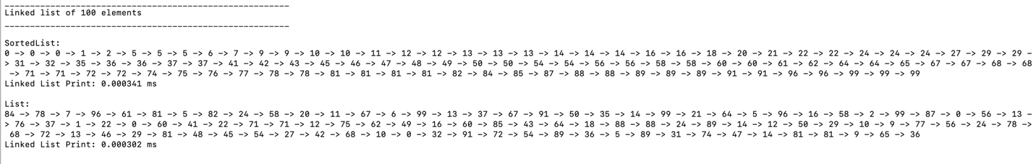

Case 2 (500)

Number of Nodes: 500

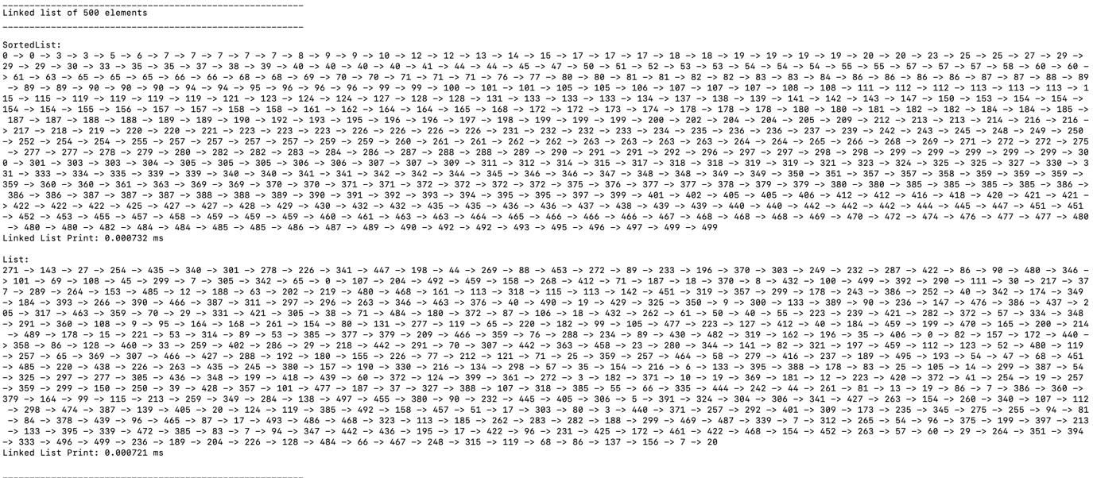

Case 3 (1000):

Number of Nodes: 1000

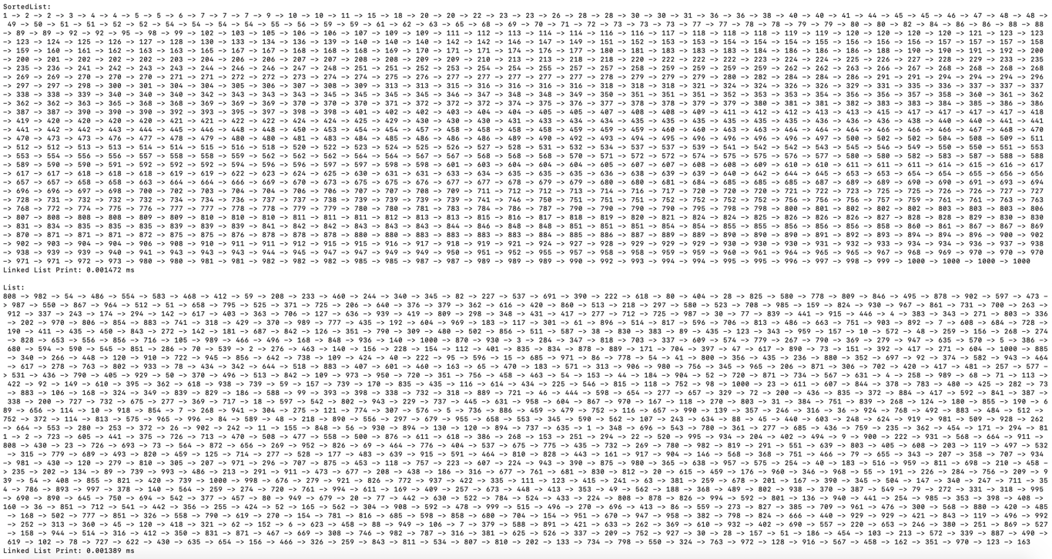

Case 4 (2000):

Number of Nodes: 2000

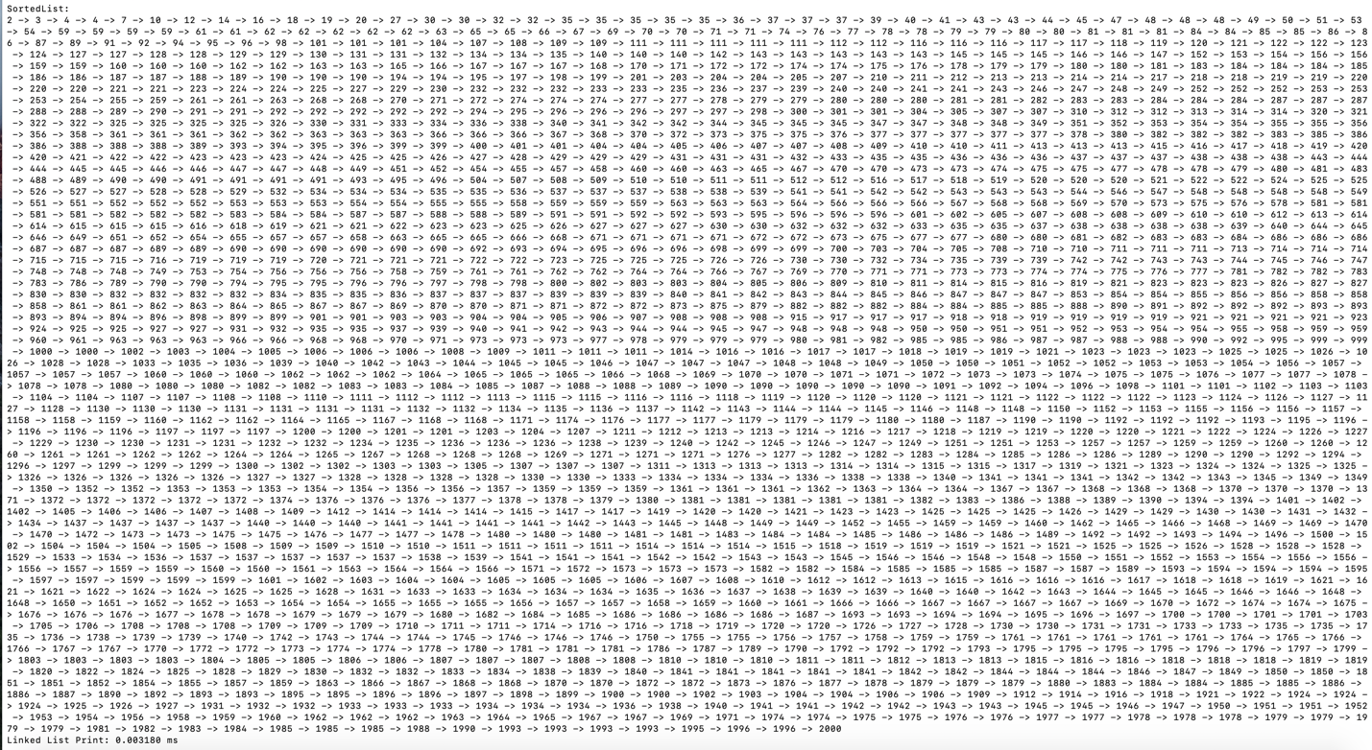

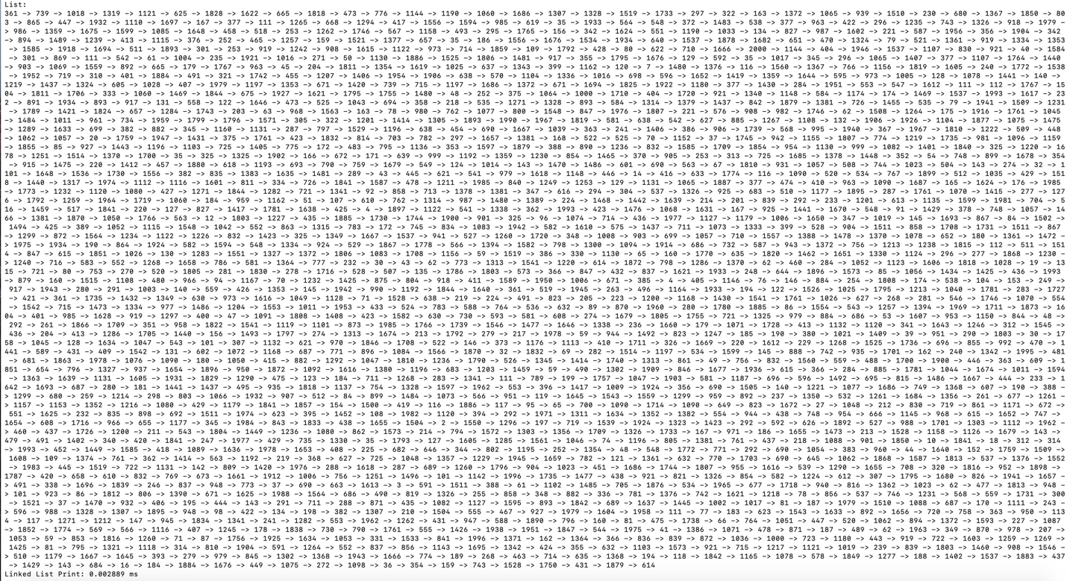





Out of all the functions, Print had one of the highest runtimes. As can be seen from the tables, Print lasted approximately 0.1 milliseconds for 2000 elements whereas the other functions were only taking 0.000200 milliseconds to iterate through the list. Despite the long performance times, it is evident from the graph that Print had a linear growth, resulting in a runtime of O(n). The reason why Print’s performance times were so long is attributed to the function’s output. Unlike the other algorithms that are performing steps internally, the Print method is consistently displaying data to the screen instantaneously. This can dramatically slow down a computer, resulting in larger performance times. As Case 4 demonstrates, a large amount of data was printed to the screen. Although Print’s performance times were dramatically larger than the other O(n) functions, its runtime still grows linearly as the number of Nodes increases. Thus, it is safe to conclude that Print has a runtime complexity of O(n).

**Insert:**

For the Insert function, a total of 3 tests were run on Lists and SortedLists of 100, 500, 1000, and 2000 Nodes. Test Case 1 measures the performance time for -1 inserted in the list. Since all of the lists tested comprised of random values from 0 to the length of the list, -1 lies outside of this range. Thus, the test case was crucial to demonstrate how SortedList would respond to the best case scenario of prepending a value. Test Case 2 measures the performance time for inserting a value greater than the tail’s value. This was also important to demonstrate a best case scenario for SortedList. To demonstrate the average case, a central value was chosen as the size of the linked list divided by two. This can be seen in Test Case 3. Lastly, Test Case 4 consists of three trials where an integer of the tail’s value minus one was inserted in the list.

Overview:

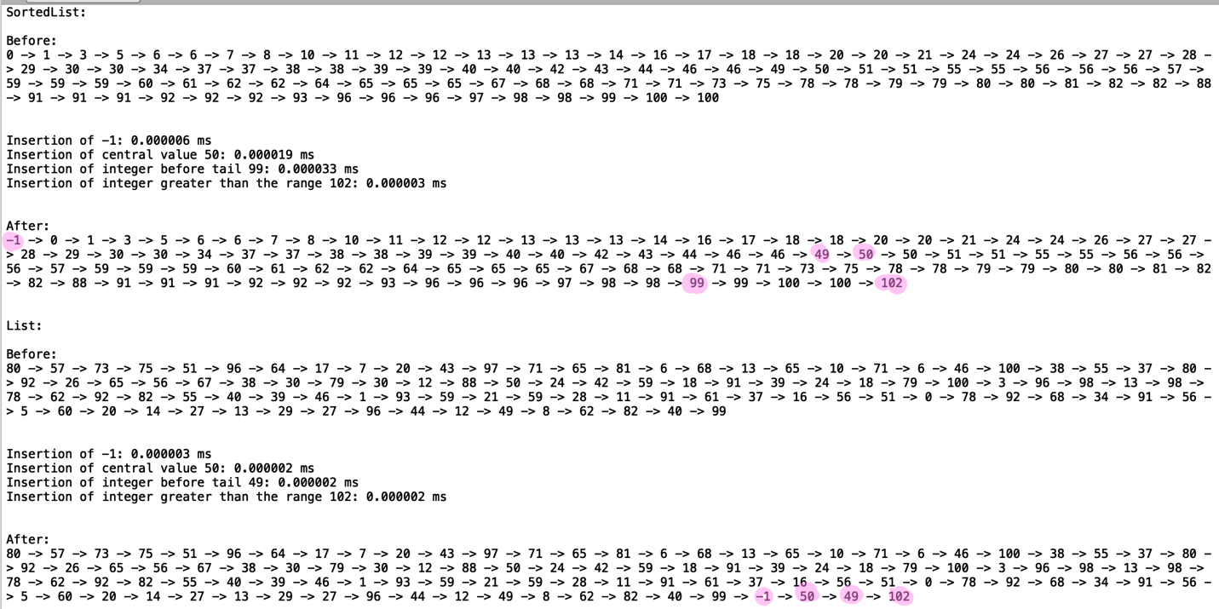

Case 1 (“-1”):

Number of Nodes= 100, 500, 1000, 2000, 3000



Case 2 (“Value Greater than List Range”):

Number of Nodes= 100, 500, 1000, 2000, 3000



Case 3 (“Central Value”):

Number of Nodes= 100, 500, 1000, 2000, 3000



Test Case 4 (“Before Tail”):

Number of Nodes= 100, 500, 1000, 2000, 3000







For all cases, List was able to insert an element within 0.000001 milliseconds. This proves that in the best, worst, and average case, List’s Insert has a runtime complexity of O(1). The runtime complexity is constant because Nodes are just appended at the end. As for SortedList, the first graph demonstrates the worst case scenario of inserting a value at the end of the list. Since the value inserted was one less than the tail, it could not be appended. Thus, the entire SortedList had to be iterated through. The list also had to be iterated through to insert a central value. This resulted in a linear growth rate which can be seen in the graphs. Lastly, the best case scenario of inserting an integer greater than the tail or less than the head, is demonstrated in the second graph. Since a value is simply appended or prepended to the List, the best case scenario of SortedList’s insertion is clearly O(1).

**Delete:**

For the Delete function, a total of 3 tests were run on Lists and SortedLists of 100, 500, 1000, and 2000 Nodes. Test Case 1 measures the performance time for deleting an integer at the head of the list and Test Case 2 measures the performance time for deleting an integer at the tail of the list. These tests were crucial to evaluate the differences between List and SortedList. As for Test Case 3, a randomly generated integer, within the list’s range, was selected to be deleted. This allowed for further analysis of List’s and SortedList’s average runtime.

Overview:

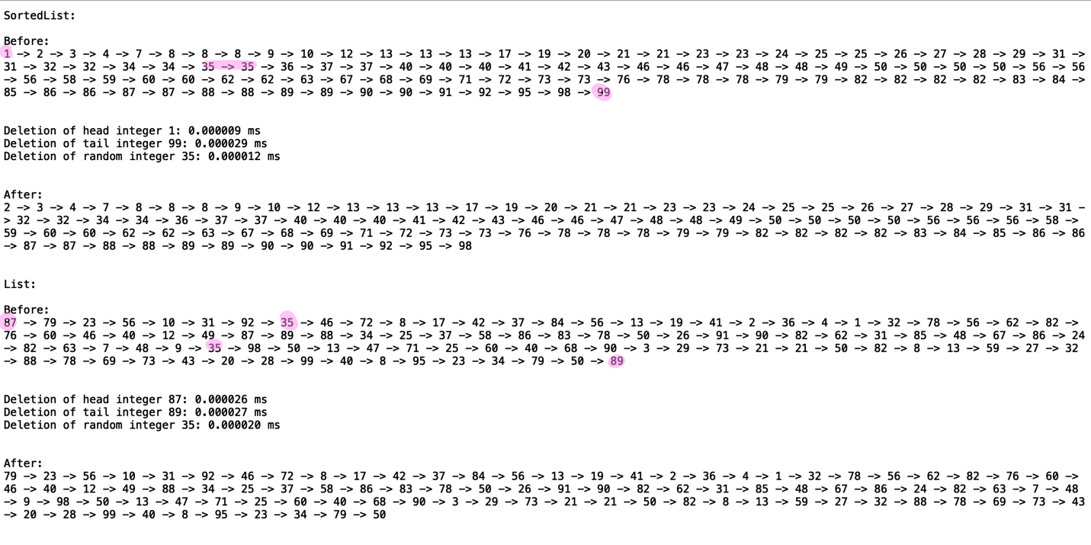

Case 1 (“Head”):

i = integer at the head of the list

Number of Nodes= 100, 500, 1000, 2000, 3000



Case 2 (“Tail”):

i = integer at the tail of the list

Number of Nodes= 100, 500, 1000, 2000, 3000



Case 3 (“Random”):

i = integer from [0, size]

Number of Nodes= 100, 500, 1000, 2000, 3000





The graph summarizing the results from Case 1 to Case 3 demonstrates that on average, the performance time for deleting any element in List is linear. Since List is unordered, the entire list must be traversed through. Thus, the runtime complexity for the best, worst, average case is O(n). As for SortedList, its best case scenario is replicated in Case 1. By deleting the integral element at the head, the list does not have to be entirely searched through, resulting in O(1). However, it is important to note that if the list consisted of all integers equal to i, except for the last Node, then the worst case scenario of O(n) would occur because the entire list would have to be iterated. This runtime of O(n) can further be seen for the SortedList when a randomly selected integer or integer at the tail is removed. Although the list is sorted, the integer must still be found before it is deleted.

**Merge:**

For the Merge function, one test was conducted for Lists and SortedLists of 100, 500, 1000, and 2000 Nodes. For each list size, a randomly generated list of half the size was created. This list was then merged with the SortedList or List. The test was run a total of three times and the trials can be viewed below in Test Case 1. By picking lists of half the size, a general approximation of the Merge function could be attained.

Overview:

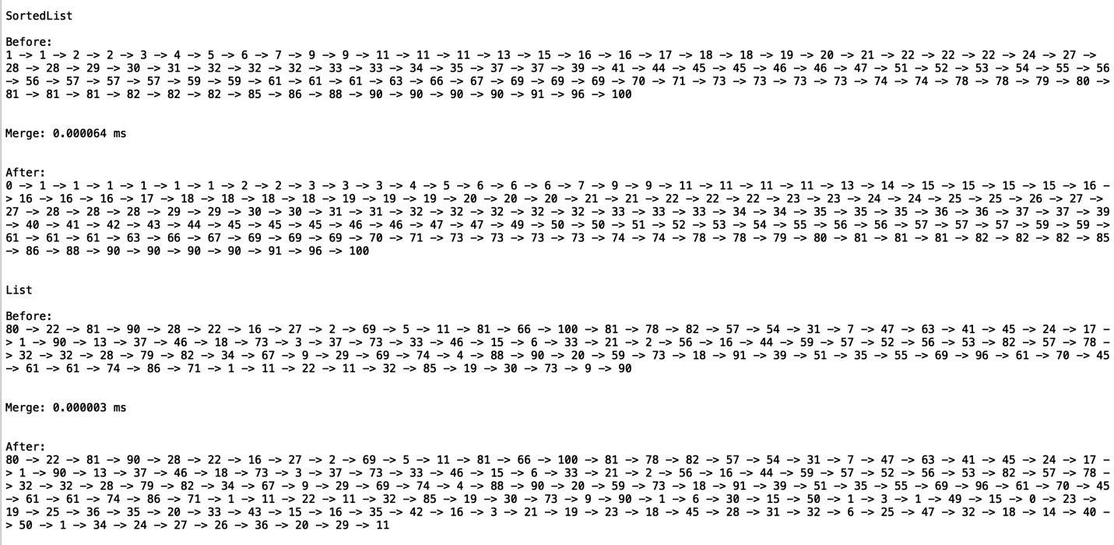

Case 1 (“Merge”):

Number of Nodes in M = 50, 250, 500, 1000, 1500

Number of Nodes= 100, 500, 1000, 2000, 3000





The graph above summarizing the performance times for Test Case 1 demonstrates that List, in all scenarios, was able to merge the lists in constant time. Since order does not matter, the second list was simply appended to the first list. This proved the average, best, and worst runtime complexity of O(1). As for the SortedList’s Merge, the runtime complexity was high, but the growth rate continued linearly. Since the Big-O notation focuses more on iterations, it does not account for other operations such as removing nodes and reassigning pointers. Although these are not considered in Big–O notation, their effect on the algorithm’s performance time can be seen through the graph. In all, the tests prove SortedList’s worst and average case for Merge as O(n).

**IndexOf:**

For the IndexOf function, four tests were conducted for List and SortedList of 100, 500, 1000, and 2000 Nodes. In order to show the best case and worst scenarios of the SortedList, Case 1 and Case 2 search for the index of the integer at the head and tail. The average case for both the SortedList and List function was tested by searching for a random integer within the list’s range in Case 3. Lastly, in order to demonstrate the best case scenario of SortedList, an integral value of the list’s size plus two was searched for in Case 4. This was an important test since it was hypothesized that the SortedList would return the index in constant time. List, on the other hand, would have to traverse through the entire list.

Overview:

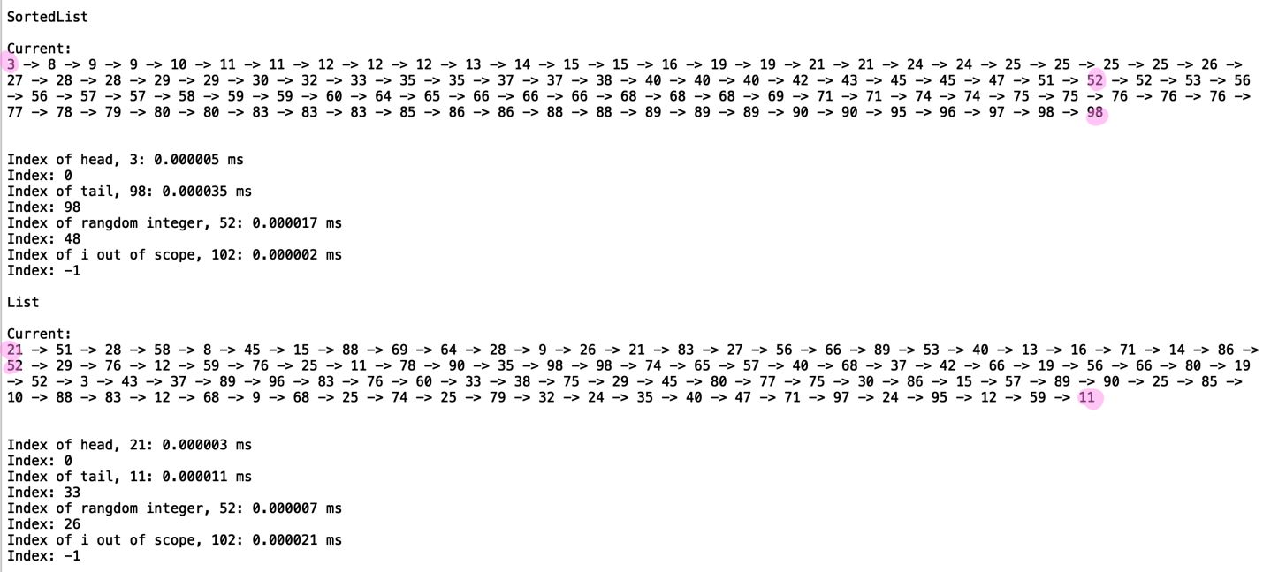

Case 1 (“Head”):

i = integer at head

Number of Nodes= 100, 500, 1000, 2000, 3000



Case 2 (“Tail”):

i = integer at tail

Number of Nodes= 100, 500, 1000, 2000, 3000



Case 3 (“Random”):

i = random integer within from [0, size]

Number of Nodes= 100, 500, 1000, 2000, 3000



Test Case 4 (“Out of Scope”):

i = size plus 2

Number of Nodes= 100, 500, 1000, 2000, 3000







The graphs above summarizing Case 1 to Case 4, demonstrates the average runtime complexity for IndexOf. From the graphs, the best case scenario of returning the index of an integer at the head or an integer out of scope, can be seen for SortedList. The function was able to successfully return the index, if it existed, in constant time. As for the average and worst case scenario, the first graph demonstrates that when returning the index of the SortedList’s tail value, the runtime complexity is O(n) since the entire list needs to be iterated through. List, like SortedList, also has a best case runtime complexity of O(1) if the integer to be found is at the head of the list. In all other instances, the list must be traversed through resulting in a runtime complexity of O(n).

**Clear:**

For the Clear function, one test was conducted for Lists and SortedList of 100, 500, 1000, and 2000 Nodes. The test consisted of three trials and each trial consisted of the designated number of Nodes being deleted from the list.

Overview:

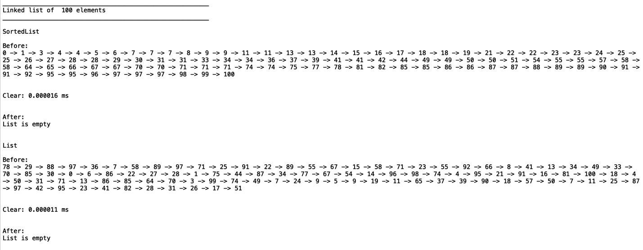

Case 1 (“Clear”):

Number of Nodes= 100, 500, 1000, 2000, 3000





The graph above summarizing Test Case 1, demonstrates, that clearing the list was almost achieved in constant time. Unlike the other constant time operations of 0.000001 milliseconds, the Clear function’s performance time did grow as the number of Nodes increased. However, this increase is probably due to Python’s garbage collector. Although the algorithm itself is just reassigning the head and tail to None, it is removing any references that point to the list. This internally causes the program to delete the objects, resulting in an increase in performance time. Thus, the average, best, and worst case scenario is O(1) for the algorithm, however, the internal implementation of Python’s garbage collector seems to require more time as more objects are deleted.

**Min and Max:**

For the Min and Max function, one test was conducted for Lists and SortedLists of 100, 500, 1000, and 2000 Nodes. The Min and Max function tests had a total of three trials and the performance times for each can be seen below.

Case 1 (“Min”):

Number of Nodes= 100, 500, 1000, 2000



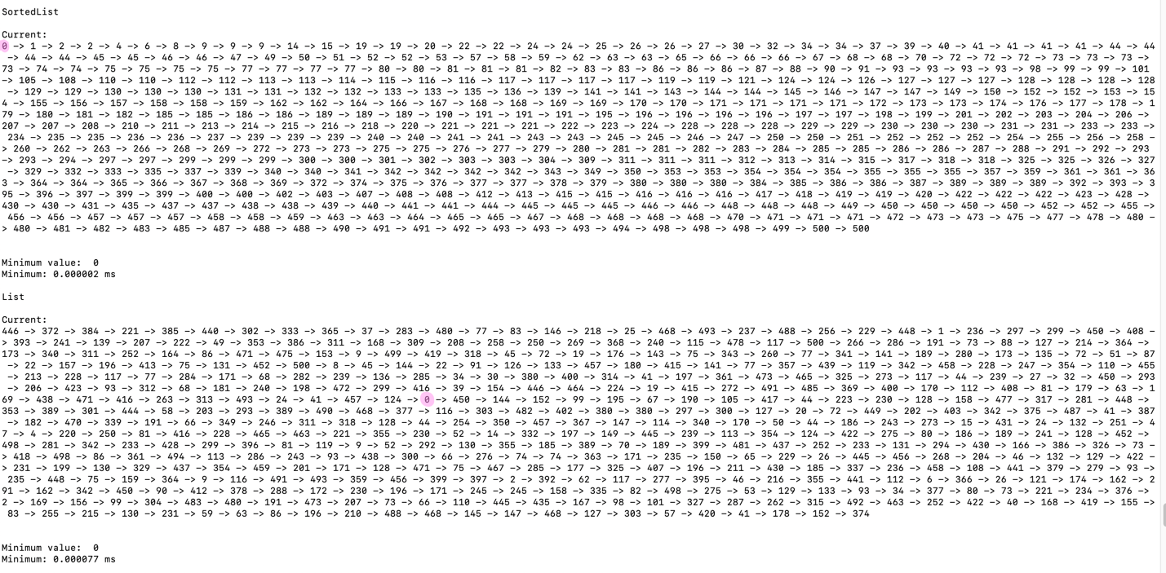

Case 2 (“Max”):

Number of Nodes= 100, 500, 1000, 2000



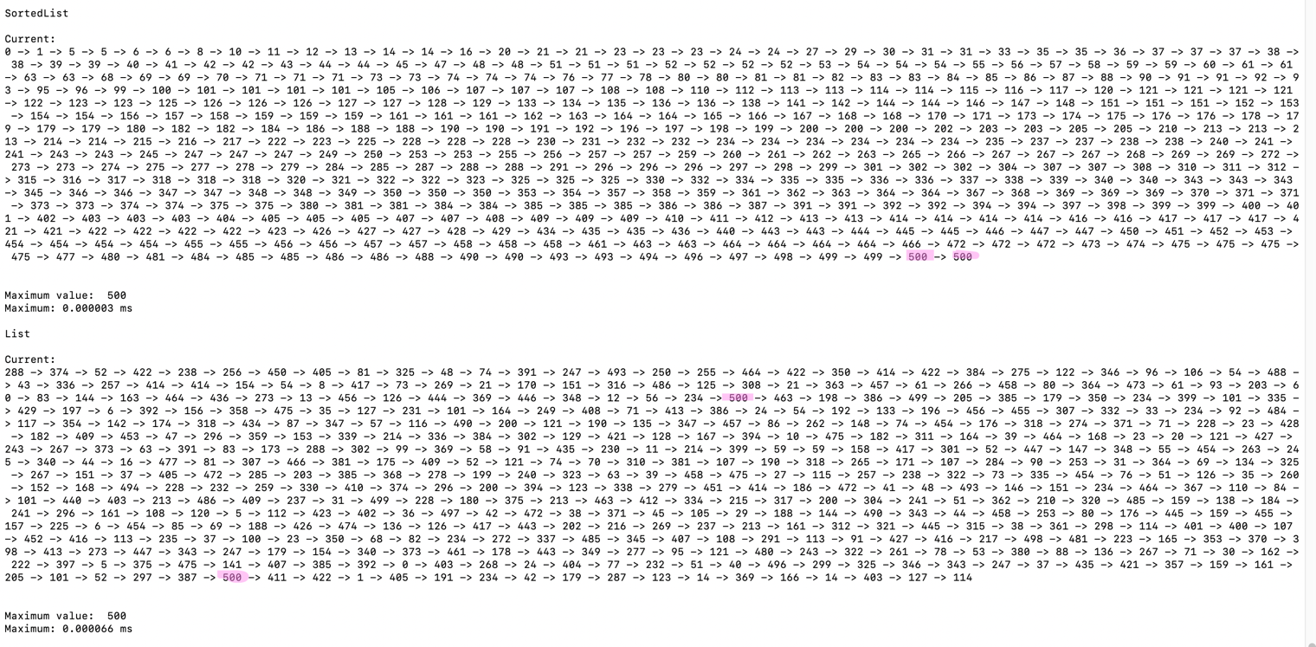



The graph above summarizing Test Case 1 to Test Case 3, demonstrates the average, best, and worst case runtime complexity for SortedList’s and List’s Max and Min. As depicted, the SortedList is able to return the minimum and maximum value within constant time. This is because the head references the minimum value of the list and the tail references the maximum value of the list. As for List, the retrieval of the minimum and maximum value is always O(n), unless the list is empty. Since the elements are not ordered, the entire list must be iterated through. Once the end of the list is reached, the function is able to accurately determine the correct value, since it has compared the minimum and maximum with all the other Node’s integers.

**HasDuplicates:**

For the HasDuplicates function, two tests were conducted for Lists and SortedLists of 100, 500, 1000, and 2000 Nodes. In order to show the best case and worst scenarios of the SortedList, Case 1 and Case 2 demonstrate the algorithm applied to a list with duplicates and a list without duplicates. Both tests were run a total of three times. The items in the duplicates list was randomized, whereas the lists without duplicates for were created from a pattern of 0, 2, 4, 6, 8, … until the half of the list was reached. The other half was created from a pattern of 1, 3, 5, ….

Overview:

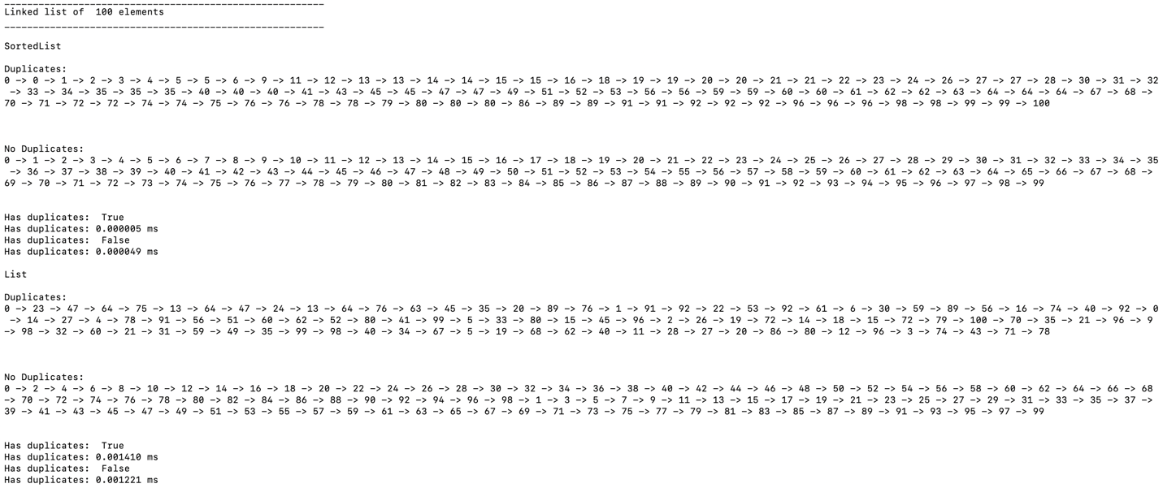

Case 1 (“Duplicates”):

Number of Nodes= 100, 500, 1000, 2000, 3000



Case 2 (“No Duplicates”):

Number of Nodes= 100, 500, 1000, 2000, 3000





The graph above summarizing Case 1 and Case 2 demonstrates the differences in performance time between SortedList and List. Since SortedList is already ordered, the current and next Node data can be compared. Thus, in the worst case, all of the Nodes’ values need to be compared. Case 2 clearly shows that SortedList’s HasDuplicates has a worst case time complexity of O(n). As for Case 1, SortedList has even lower performance times probably due to duplicates that existed near the front of the list. For List, in all instances, the performance time closely resembled the proposed performance time for O(nlogn). As the number of Node’s increases, the performance time steeply increases. Since the List needs to be sorted before checking for duplicates, the MergeSort’s runtime complexity of O(nlogn) is clearly shown.

**Select:**

For the Select function, three tests were conducted for Lists and SortedLists of 100, 500, 1000, and 2000 Nodes. In order to show the different scenarios that could occur, Case 1 and Case 2 find the 0th smallest element and the largest element in the list. Case 3 takes a more generalized approach and randomly selects a kth element to find. This case was crucial since varying indices result in different list partitions.

Overview

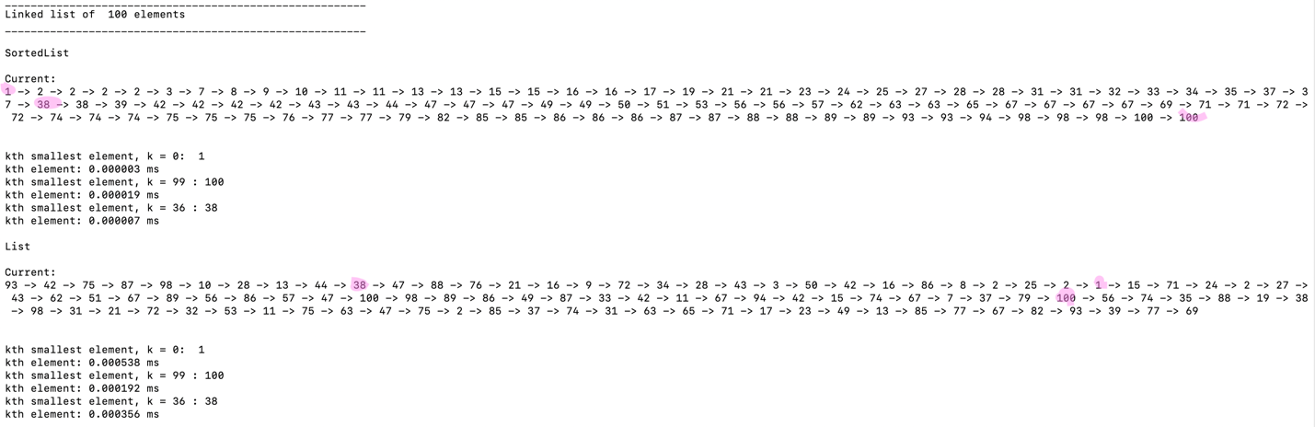

Case 1 (“k = 0”):

k = 0

Number of Nodes= 100, 500, 1000, 2000, 3000



Case 2 (“Tail”):

k = last element

Number of Nodes= 100, 500, 1000, 2000, 3000



Case 3 (“Random”):

k = random index

Number of Nodes= 100, 500, 1000, 2000, 3000





The graph above summarizing Test Case 1 to Test Case 3, demonstrates that the performance time for Select was always longer for List. This is because the Modified QuickSort is used to sort parts of the list where the kth element resides. Although the performance times vary from SortedList, they are still linear. Thus, it can be concluded that the average runtime complexity is O(n). It is also important to note that List’s Select may have a higher runtime complexity due to the pivot selection. Since the list needs to be iterated through to find a central pivot, a longer performance time occurs. Additionally, if the pivot is consistently the lowest or smallest value, then the performance time would be further prolonged, resulting in a worst case runtime complexity of O(n^2). As for the SortedList, its best case runtime complexity of O(1) is clearly seen in Case 1, since the 0th element is returned in constant time. As for the other Cases, the SortedList is growing linearly resulting in O(n).

**Worst Case Performance Time Comparison:**

The graphs below demonstrate the worst case performance times for all the function, except for Print, below. Print is excluded from these comparisons since its main operation is different, resulting in different performance times. As noted, Print is constantly displaying data, resulting in higher performance times. The data depicted in the first and second graph demonstrates how all the other linear and constant runtime complexities compare to HasDuplicate’s O(nlogn) runtime complexity. In addition to the tests described above an additional test for 3000 Nodes was created to demonstrate the performance times for the functions. As for the third and fourth graphs, the varying linear and constant runtime complexity among the functions is demonstrated.







By viewing the graphs above, it is very clear that List’s HasDuplicates had the worst runtime complexity. In theory, List’s HasDuplicates has a worst case time complexity of O(nlogn). As for List’s Select, it had higher performance times then the other O(n) classified functions, but its growth rate is evidently linear. The reason why List’s select has larger performance times is because the list is iterated several times to find the pivot and to perform partitions. As for the other functions, a majority of their runtime complexities are linear and constant. From the third and seconds graph, it is evident that SortedList Min, SortedList Max, List Merge, and List Insert are O(1). As for SortedList’s Merge, its runtime complexity is closer to List’s Select. Both the Insertion and Deletion functions of SortedList are clearly O(n). List’s and SortedList’s Clear have a higher performance time than SortedList’s Min, demonstrating that Python is internally using a garbage collector. The table below summarizes the Big-O running times for the SortedList’s and List’s functions discussed above.

|  |  |  |
| --- | --- | --- |
| Big-O Running Times | | |
| Function | SortedList | List |
| Print | O(n) | O(n) |
| Insert(i) | O(n) | O(1) |
| Delete(i) | O(n) | O(n) |
| Merge(M) | O(n) | O(1) |
| IndexOf(i) | O(n) | O(n) |
| Min() | O(1) | O(n) |
| Max() | O(1) | O(n) |
| HasDuplicates() | O(n) | O(nlogn) |
| Select() | O(n) | O(n) |

**Conclusion**

In all, I learned that the performance time of LinkedList’s can largely vary, even if they are grouped under the same Big-O notation category. As can be seen from the graphs, for a single iteration of a list, the running times can drastically vary. For the Print function the performance time for 2000 elements was approximately 0.1 milliseconds whereas List’s Max performance time was approximately 0.0002 milliseconds. Both functions iterated through the List, but the performance times varied due to the outputs of the Print function. As for Clear, although reference assignments are constant times, the performance times were still slightly higher. This suggests the use of python’s garbage cleaner internally. Additionally, this lab gave me a better insight on how to implement sorting functions with linked lists. Before completing this lab, I had never applied a sorting algorithm on a linked list. However, since HasDuplicates requires the list be sorted, I decided to sort a copy of the list instead. I did not use Python’s native List to sort the elements, because I wanted to ensure that all processes were entirely operated by linked lists. In doing so, I was able to learn more about this data structure. One interesting topic that I learned about was that you can almost treat linked lists like arrays, but it requires more work. For the Partition method, I kept an index counter which was incremented every time a Node was added to the left sub-list. I was thus able to keep track of which kth element existed in a list. However, unlike arrays, you cannot immediately access any index. One can only keep track of the current Node, demonstrating a limitation of linked lists. Lastly, I learned how to compare a program’s performance against the Big O-notation. When I was calculating the performance times, I realized that I needed to directly compare the results with the Big O-notation functions. In the previous lab, I used the number of comparisons to directly compare the Big-O notation. Since this lab focuses only on the running times, I realized that I needed to find another way to compute the Big-O notation for performance times. In order to do so, I plotted my data and compared the slopes of the graphs to varify the corresponding Big-O notations.

**Appendix A**

I certify that this project is entirely my own work. I wrote, debugged, and tested the code being presented, performed the experiments, and wrote the report. I also certify that I did not share my code or report or provided inappropriate assistance to any student in the class.

X



-----------------------------------